60004210210

Amartya Mishra

COMPS – C31

ML Experiment 6

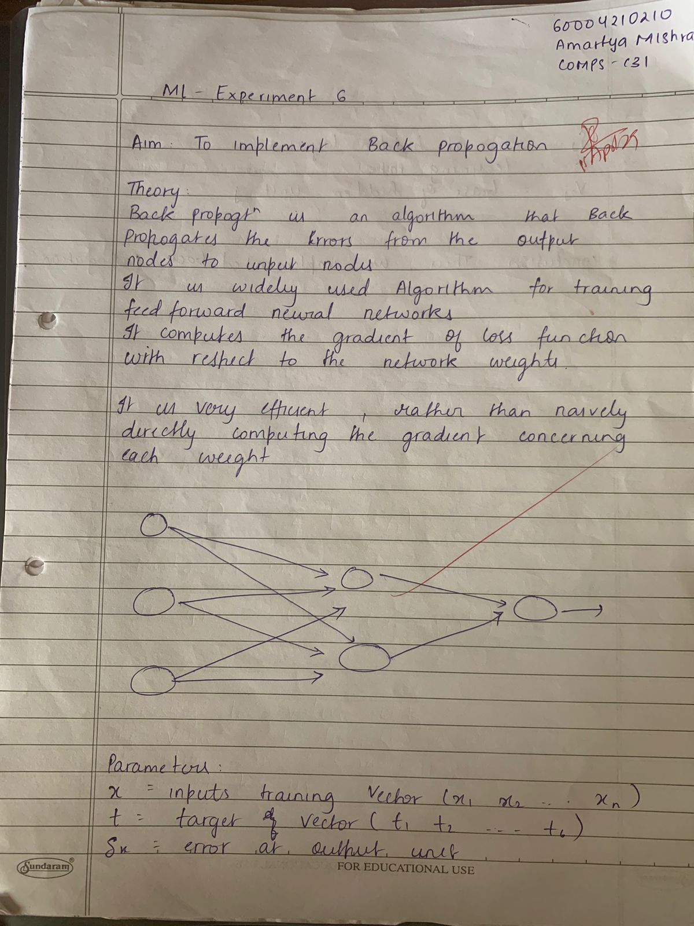



**Implementation:**

import numpy as np

class NeuralNetwork:

def __init__(self, input_size, hidden_size, output_size):

self.input_size = input_size

self.hidden_size = hidden_size

self.output_size = output_size

# Initialize weights and biases

self.weights_input_hidden = np.random.randn(self.input_size,

self.hidden_size)

self.bias_input_hidden = np.random.randn(1, self.hidden_size)

self.weights_hidden_output = np.random.randn(self.hidden_size,

self.output_size)

self.bias_hidden_output = np.random.randn(1, self.output_size)

def sigmoid(self, x):

return 1 / (1 + np.exp(-x))

def sigmoid_derivative(self, x):

return x * (1 - x)

def forward(self, inputs):

self.hidden_input = np.dot(inputs, self.weights_input_hidden) +

self.bias_input_hidden

self.hidden_output = self.sigmoid(self.hidden_input)

self.final_input = np.dot(self.hidden_output,

self.weights_hidden_output) + self.bias_hidden_output

self.final_output = self.sigmoid(self.final_input)

return self.hidden_output, self.final_output

def backward(self, inputs, targets, learning_rate):

error = targets - self.final_output

delta_output = error * self.sigmoid_derivative(self.final_output)

delta_hidden = np.dot(delta_output, self.weights_hidden_output.T) *

self.sigmoid_derivative(self.hidden_output)

self.weights_hidden_output += np.dot(self.hidden_output.T,

delta_output) * learning_rate

self.bias_hidden_output += np.sum(delta_output, axis=0,

keepdims=True) * learning_rate

self.weights_input_hidden += np.dot(inputs.T, delta_hidden) *

learning_rate

self.bias_input_hidden += np.sum(delta_hidden, axis=0,

keepdims=True) * learning_rate

return error

def train(self, inputs, targets, learning_rate):

hidden_output, final_output = self.forward(inputs)

error = self.backward(inputs, targets, learning_rate)

print("Output of hidden layer:")

print(hidden_output)

print("Output of output layer:")

print(final_output)

print("Error found:")

print(error)

print("Updated weights after 1 iteration:")

print("Weights from input to hidden layer:")

print(self.weights_input_hidden)

print("Weights from hidden to output layer:")

print(self.weights_hidden_output)

dataset = pd.read_csv('reduced_digits_dataset.csv')

inputs = dataset.drop(columns=['target']).values

targets = dataset['target'].values.reshape(-1, 1)

input_size = inputs.shape[1]

output_size = len(np.unique(targets))

hidden_size = 3

nn = NeuralNetwork(input_size, hidden_size, output_size)

nn.train(inputs, targets, learning_rate=0.1)